DESIGN PROJECT PROPOSAL FORM
Academic Year | 2022 - 2023 | Semester |  | Fall Spring
Project Type | Research |  | Application
 | ME 411 Thermal & Fluid Design |  | ME 412 Thermal & Fluid Design
 | ME 413 Mechanical Design |  | ME 414 Mechanical Design
 | ME 415 Robotics & Control Design |  | ME 416 Robotics & Control Design
Advisor | Prof. Dr. Mehmet Çevik

Project Title | Design and Fabrication of a Gearless Transmission Using Elbow Mechanism
Purpose and Scope | The purpose of the project is to design and manufacture a gearless transmission using elbow mechanism. The elbow mechanism is an efficient design of gearless transmission technique and the kinematic system that allows for efficient power/motion transmission at any required angle. This mechanism should allow for motion transmission from 90° to 180° angles between the driver and the driven shafts. Use a motor powered by 12V supply, rotate a shaft, and transmit this rotation at the given angles between the driver and the driven shafts. The design success criterion is that the motion transmission will be from 90° to 180° angles.  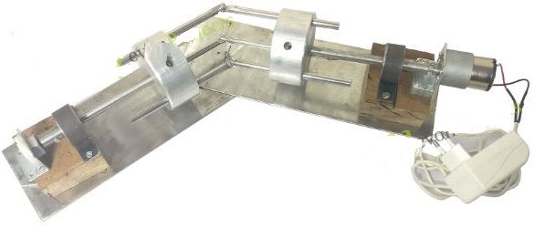
Work Packages | - Make a literature review about excavators  - Determine design criteria  - Prepare a Solidworks model that is working  - Manufacture the excavator and test it  - Prepare the project report.
# of Team Members | 2
This section will be filled by the Commission | The Project Proposal  - fulfills the regulations of the Department  - should be revised according to the following suggestions:

The projects are aimed to prepare students to attain the following program educational objectives:
(a) an ability to apply knowledge of mathematics, science, and engineering
(b) an ability to design and conduct experiments, as well as to analyze and interpret data
(c) an ability to design a system, component, or process to meet desired needs within realistic constraints such as economic, environmental, social, political, ethical, health and safety, manufacturability, and sustainability
(d) an ability to function on multidisciplinary teams
(e) an ability to identify, formulate, and solve engineering problems
(f) an understanding of professional and ethical responsibility
(g) an ability to communicate effectively
(h) the broad education necessary to understand the impact of engineering solutions in a global, economic, environmental, and societal context
(i) a recognition of the need for, and an ability to engage in life-long learning
(j) a knowledge of contemporary issues
(k) an ability to use the techniques, skills, and modern engineering tools necessary for engineering practice.

Therefore, the final report of the project should contain the followings:
- Definition of the design problem and its limitations
- Theoretical information about the topic, standards and patents
- Different design options and selection criteria
- Optimal solution with appropriate selection criteria
- Cost accounting, feasibility, compliance with regulations and standards, environmental impacts, and compliance with ethical rules
- Engineering drawing and presentation methods for presenting

