DESIGN PROJECT PROPOSAL FORM
Academic Year | 2024 - 2025 | Semester |  | Fall Spring
Project Type | Research |  | Application
 | ME 411 Thermal & Fluid Design |  | ME 412 Thermal & Fluid Design
 | ME 413 Mechanical Design |  | ME 414 Mechanical Design
 | ME 415 Robotics & Control Design |  | ME 416 Robotics & Control Design
Advisor | Prof. Dr. Mehmet Çevik

Project Title | Designing and Manufacturing a Shredder Machine
Purpose and Scope | This project involves designing and manufacturing a shredder machine for a small-sized enterprise specializing in plastic molding. The shredder will be used to process plastic waste into smaller, uniform pieces suitable for recycling and reuse within the production process. The student will collaborate closely with the enterprise to understand their specific requirements, such as capacity, material types, and operational constraints. The project aims to enhance the company’s sustainability efforts by minimizing plastic waste and reducing raw material costs, while providing the student with hands-on experience in machine design and manufacturing.  This project combines sustainability with practical engineering, offering the student valuable experience in machine design, material selection, and collaboration with industry.  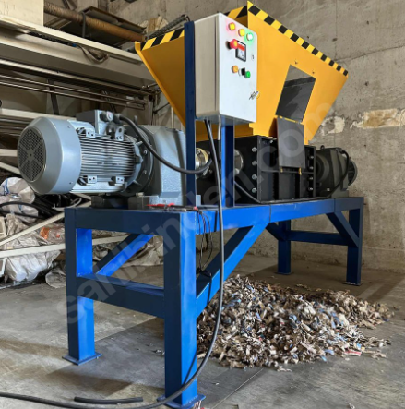
Work Packages | - Collaborating with the company to assess their requirements and analyze the types and volumes of plastic waste to be shredded.  - Conducting a literature review on existing shredder machines and their design principles.  - Defining design specifications, including shredder dimensions, motor power, blade configuration, and safety features.  - Creating a 3D model of the shredder using CAD software to visualize the design and refine details.  - Selecting appropriate materials for the shredder components, ensuring durability and cost-efficiency.  - Manufacturing the shredder machine, including assembly and quality checks.  - Testing the machine with different plastic materials to validate performance and make necessary adjustments.  - Preparing a project report, documenting the design, manufacturing, and testing processes, along with the outcomes.
# of Team Members | 3
This section will be filled by the Commission | The Project Proposal  - fulfills the regulations of the Department  - should be revised according to the following suggestions:

The projects are aimed to prepare students to attain the following program educational objectives:
(a) an ability to apply knowledge of mathematics, science, and engineering
(b) an ability to design and conduct experiments, as well as to analyze and interpret data
(c) an ability to design a system, component, or process to meet desired needs within realistic constraints such as economic, environmental, social, political, ethical, health and safety, manufacturability, and sustainability
(d) an ability to function on multidisciplinary teams
(e) an ability to identify, formulate, and solve engineering problems
(f) an understanding of professional and ethical responsibility
(g) an ability to communicate effectively
(h) the broad education necessary to understand the impact of engineering solutions in a global, economic, environmental, and societal context
(i) a recognition of the need for, and an ability to engage in life-long learning
(j) a knowledge of contemporary issues
(k) an ability to use the techniques, skills, and modern engineering tools necessary for engineering practice.

Therefore, the final report of the project should contain the followings:
- Definition of the design problem and its limitations
- Theoretical information about the topic, standards and patents
- Different design options and selection criteria
- Optimal solution with appropriate selection criteria
- Cost accounting, feasibility, compliance with regulations and standards, environmental impacts, and compliance with ethical rules
- Engineering drawing and presentation methods for presenting

